

Business Plan

Contact: | David Cornelson
1144 East State St. Suite A
Geneva, IL 60134
Voice: (630) 803-4302
Fax: (630) 206-0678
david@textfyre.com

Table of Contents

1.0 Executive Summary 3
2.0 Company Overview 5
2.1 Mission Statement 5
2.2 Textfyre’s Products 5
2.3 Current and Future Products 5
2.4 Development to Date 6
3.0 Industry Analysis & Trends 7
3.1 History and Background 7
3.2 Industry Size and Composition 7
3.3 Electronic Reading Trends 7
3.4 Overall Gaming Industry Trends 9
3.4 Sales & Genres 10
4.0 Market Analysis 11
4.1 Literate Casual Gamers 11
4.2 Readers 11
5.0 Competitive Analysis 12
5.1 Direct Competition 12
5.2 Indirect Competition 12
5.3 Textfyre’s Competitive Strengths 12
6.0 Marketing & Sales Strategy 13
6.1 Roll-Out Strategy 13
6.2 Advertising & Promotional Strategy 13
6.3 Pricing 15
6.4 Sales Strategy 15
7.0 Operations Plan 16
7.1 Location 16
7.2 Contractor Compensation 16
7.3 Customer Returns 16
7.4 R&D Schedule 16
8.0 Management & Organization 17
8.1 Key Personnel 17
8.2 Ownership and Advisors 17
9.0 Future Development 18
10.0 Financials 19
10.1 Sources & Uses of Funds 19
10.2 Assumptions 19
10.3 Financial Analysis 19

1.0 Executive Summary

Textfyre, Inc. was formed as a subchapter S corporation in 2007 by founder David Cornelson. The business is located in Geneva, IL and publishes text-based interactive stories to desktop, notebook, and mobile platforms.

Interactive Fiction has been around since the late 1970s, but lost ground to video games in the mid to late 1980s. Despite the lack of commercial success in recent years, interactive fiction has been sustained by enthusiasts who create and freely distribute their products. With the rise of the casual gaming and electronic reading, Mr. Cornelson saw an opportunity to bring interactive fiction back to the commercial market.

Currently, only one competitor commercially sells Interactive Fiction, Malinche Entertainment. This company has five titles available including murder mysteries, action adventures, and horror. Another direct competitor, Tabula Digita, develops online games to help students improve their algebra skills. Indirect competitors include video games, books, and other learning software. Textfyre intends to differentiate itself by providing a publishing pipeline to all computer platforms. Textfyre will develop its own material, but also accept material from external sources.

Textfyre has chosen two primary targets to market its products – literate casual gamers and readers. Textfyre believes that its entertaining, non-traditional format will be welcomed by both of these groups. As a result of this appeal, millions of mobile and computer devices will carry Textfyre’s products. Interactive fiction hobbyists nostalgic for Infocom, Level 9, and Scott Adams games will be secondary targets.

To reach these markets, Textfyre has developed a strategy to roll out new platforms every few months. It will first focus on online distribution of electronic download media. This will be followed by publishing to mobile marketplaces like the Amazon Kindle Store, the Apple App Store, the Droid marketplace, and the Windows Phone 7 Marketplace.

Textfyre is managed by its founder, David Cornelson. Mr. Cornelson oversees all aspects of the company, especially its game development contractors. Upon launch, Textfyre will bring on a full-time CEO and CFO to manage the business
.
Textfyre has assembled a team of writers, designers, and programmers to assist in game and platform development. These team members are currently contractors, but integral roles will be hired as full-time employees starting in 2011. Sales and marketing professionals will also be sought to round out the management team. The company has a well-rounded advisory board to assist Mr. Cornelson in strategy development and execution.

To date, Textfyre has completed its first and second products. One title was launched to the hobbyist market in June of 2009 and the second launched in November of 2009. A third product is in beta testing and will be released in Q4 2010. A fourth series was announced in Q1 2010 that will reach the market in 2011. Two sequels are planned or all four series’. Textfyre is also seeking external content which will be published immediately to all platforms.

This launch strategy promises to be fruitful for the company, with revenues growing from $850,000 in 2011 to $4.9 million in 2014. Profit margins remain strong due to the number of titles available and operational efficiencies.

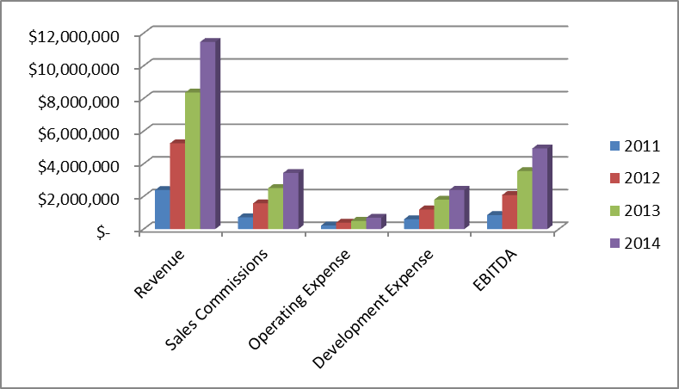

2.0 Company Overview

Textfyre, Inc., was founded in 2006 by David Cornelson and is based in Geneva, IL. Textfyre produces interactive fiction that simultaneously entertains and challenges its reader. Interactive Fiction brings books to life by enabling the reader to choose the actions of the main character and become a part of the story.

The idea for Textfyre was initially born as a hobby of the founder. The interactive Fiction industry was popularized in the 1980s, however early companies didn’t adapt to the video game market or were absorbed by video game companies, which didn’t see a value in continuing to publish high quality Interactive Fiction. The medium was quietly maintained by hobbyists who developed development tools, game engines, and their own stories and shared them freely with other enthusiasts over Usenet and later the Internet. As the casual gaming and electronic reading markets continue to grow, Mr. Cornelson sees an opportunity to bring interactive fiction back to the market.

2.1 Mission Statement
Textfyre will produce, procure, and publish high quality Interactive Fiction to all electronic platforms.

2.2 Textfyre’s Products
Textfyre will be a publisher of Interactive Fiction starting with internally developed content followed by externally licensed or contracted material. The player can read along with the story as well as interact with the characters, influence the setting; all by typing natural language commands. The characters follow the direction of the reader and the story changes in response to the reader’s commands. This interaction allows the game to be played multiple times without duplication.

Key features of each story include:

- The story will consist of basic movement commands such as: go north, go south, open door, go up and go down.
- As the player continues through the story, more complex language offer more interactivity for the player, such as: climb the north wall or open the gold chest with the silver key.
- Other characters in the story can provide help when asked offering a simulated or artificial intelligence feel to the story.
- Players do not have to go page by page in a linear fashion; they have the freedom to move to and from different sections of the story’s setting.

Each product will include an introduction, the story, embedded help and hints, along with modes for new and experienced readers.

2.3 Current and Future Products
Textfyre’s first product is a part of the Miradania Series called “Jack Toresal and The Secret Letter.” This offering involves a young female character, Jacqueline “Jack” Toresal. Jack is a fourteen year old orphan with an education paid for by an anonymous sponsor living in a fantasy kingdom. She decides to seek out her benefactor in disguise as a boy and eventually finds she is the heir to the local lands and may be eligible for the Kingdom throne. This storyline offers adventure in a fantasy world by a character close in age to the target market.

The Miradania Series continues with “Jack Toresal and the Trial of the Vedd” and finishes with an untitled third game in 2011.

To date, three more series are in various stages of development:

- The second series, Klockwerk, begins with “The Shadow in the Cathedral” published in November of 2009 followed by two more titles in 2010 and 2011.

- The third series, Giant Leaps, begins with “The Empath’s Gift”, to be published in 2010 with two more games in 2011.

- The fourth series, Anna Chronicle, begins with Poets in Peril, to be published in 2011.

- All additional series’ are dependent on funding and/or revenue streams, but can be ramped up quickly.

Hobbyist authors as well as traditional book authors will be invited and encouraged to participate in developing Interactive Fiction either from new or existing material. These works will be published as-is and approved by a combined internal and external editorial board.

Textfyre is working with a well-known fantasy author, Janny Wurts, to develop three games in the world of Athera, part of her War of Light and Shadow series of books. The first of these would be published in 2011. Textfyre also has begun discussions with Kathleen and Michael Gear, the authors of the “People of the Earth” series of North American anthropological historical fiction novels. There have also been discussions with experts in Mesoamerican (Incan, Mayan, and Aztec) history to develop social studies content within the Interactive Fiction medium.

2.4 Development to Date
Textfyre is currently in the start-up phase of development. To date, the following tasks have been completed or are in development:

- All necessary paperwork has been filed with the city and state
- Key illustrators and programmers have been contracted
- First and second products published in June and November of 2009
- Subsequent games will be published in 2010.
- In 2011 and going forward, Textfyre will publish at least one game per month
- Character and title trademarks will be sought as games are published
- Windows, Mac OS X, and Silverlight platforms are completed.
- Work has begun on iPhone, iPad, Android, Windows Phone 7, and Kindle platforms.

3.0 Industry Analysis & Trends

3.1 History and Background
Interactive fiction was originally developed by Will Crowther in 1975 with the simple game Adventure. Don Woods of the Stanford Artificial Intelligence Laboratory re-envisioned Adventure with more advanced technology and an expanded storyline in 1977. Both versions of the game ignited interest in interactive fiction and led to its widespread success in the 1980s.

Infocom was the largest company to produce interactive fiction and released a number of very popular titles before being acquired in 1986 by Activision, a well known computer and video game company. The rise of video games in the late 1980s put many of the interactive fiction producers out of business as players responded to the enhanced graphics, sounds, and technological capabilities.

Interactive fiction made a brief resurgence in the 1990s by incorporating many of the characteristics of video games, but was never able to gain significant traction or market share. All notable entrants were purchased by video game companies and incorporated into their gaming portfolio.

3.2 Industry Size and Composition
The interactive fiction industry has become a small niche market with very few producers and competitors. As mentioned earlier, most of the industry is self-produced and informally distributed for free by interactive fiction enthusiasts. Industry insiders estimate that up to thousands of new games have been developed since the birth of interactive fiction. Despite the lack of commercial support, the availability of high quality tools and competitions allow enthusiasts to develop new, high quality games.

3.3 Electronic Reading Trends
eBooks sales have skyrocketed in the last year, including a clear passing of the guard at Amazon.Com, who reports that they will “sell more Kindle books than paperback books in the next year [2011]. Sometime after that,” says Steve Kessel, “we will start selling more Kindle books than hard covers and paperbacks combined.” There are an estimated 2 to 3 million Kindles in active use. With Kindle sales moving to Target and Best Buy, there could be an estimated 8 million Kindles by the end of 2010.

Statistics pulled together by the International Digital Publishing Forum are located at their website: http://idpf.org/doc_library/industrystats.htm
- The data represent United States revenues only
- The data represent only trade eBook sales via wholesale channels. Retail numbers may be as much as double the above figures due to industry wholesale discounts.
- The data represent only data submitted from approx. 12 to 15 trade publishers
- The data does not include library, educational or professional electronic sales
- The numbers reflect the wholesale revenues of publishers
- The definition used for reporting electronic book sales is "All books delivered electronically over the Internet OR to hand-held reading devices"
- The IDPF and AAP began collecting data together starting in Q1 2006
US Trade Wholesale Electronic Book Sales
Q2 2010 = $88.7 Million
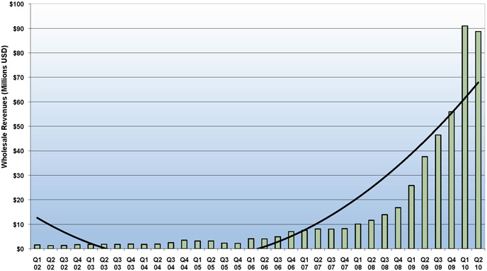

3.4 Overall Gaming Industry Trends
According to The NPD Group and the Entertainment Software Association, the gaming industry nearly tripled from $2.6 billion in 1996 to $7.4 billion in 2006. The industry appears to be maturing, leveling off at $7 billion in annual sales in recent years.

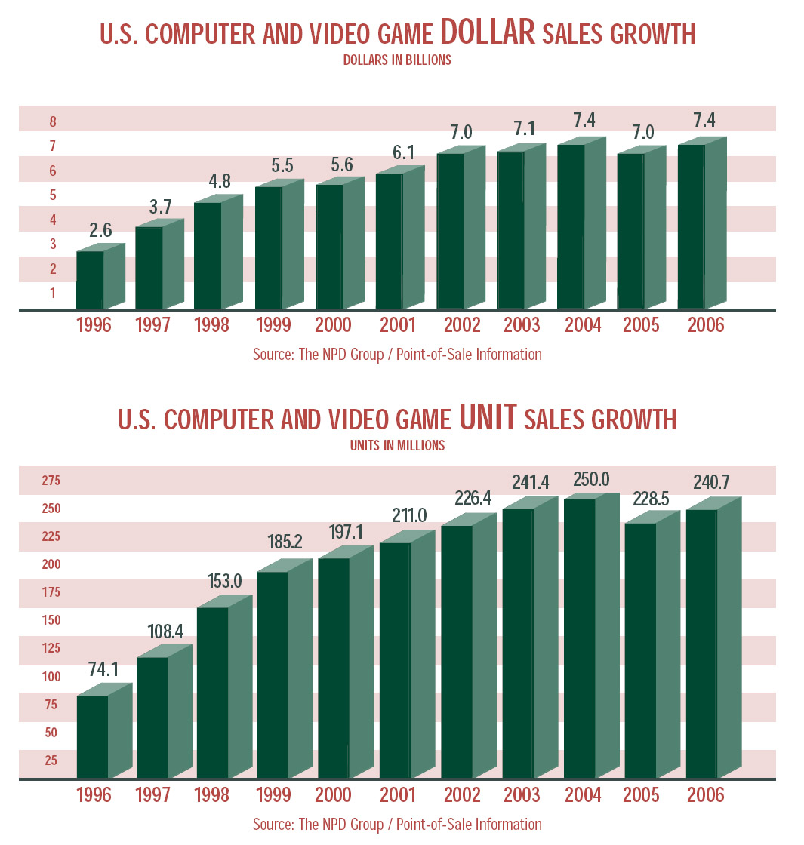

Similarly, unit sales have stayed above 225 billion games sold annually since 2002.

3.5 Sales & Genres
The Entertainment Software Association and NPD also reports that:

- Ratings – 85% of all games sold in 2006 were rated “E” for everyone, “T” for teen, or “E10+” for everyone over 10 years old. The remaining 15% of games sold were rated “M” for mature audiences.
- Video Games – 27.5% of games sold were action oriented, 17% were sports related, and family entertainment, role playing, shooter, and racing each comprised 10% of industry sales. Adventure games comprise 3.4% of the video game market.
- Computer Games – 35% of games sold were strategy, 14% were role playing, 13% were family entertainment, and 11% were shooter games. Adventure games comprise 5.7% of the computer game market.

Interactive fiction is often considered to be an adventure game and would be rated “E” for everyone. Adventure games are a type of computer entertainment program that are interactive and based on a storyline. These games follow the same story conventions as literature or film. Adventure games include genres such as: fantasy, science fiction, mystery, horror, and comedy.

4.0 Market Analysis

Textfyre will have two distinct target markets including literate casual gamers and readers. We will also target nostalgic customers of Infocom, Level 9, and Scott Adams adventures.

4.1 Literate Casual Gamers
Casual Gamers play games across a variety of genres, complexity, and difficulty. They approach gaming as a hobby and look for games that are easily accessible (usually online) and user friendly. The Casual Gamer market has begun growing steadily, with the Casual Games Association claiming a 20% increase in sales per year and a current $2.5 billion industry.

This indicates a large portion of Americans have begun using games on a casual basis but do not consider themselves “gamers.” The Casual Gamer Association notes that the casual gaming market is often underestimated and thought to be a smaller portion of the major gaming audience. The association found just the opposite, almost everyone in the country plays casual games, with the most popular games being Solitaire and Tetris.

Ran Cohen of Eyeblaster, an in-game ad firm, says that “the whole industry of the downloadable casual game is female-oriented.” He noted that 60%-70% of casual game players are females over 30.

4.2 Readers
Based on the eBooks sales statistics and the following normal books sales analysis, it’s clear that people still read.

Sales growth (or loss) over previous seven years

Company - %'s all rounded | 2009 | 2008 | 2007 | 2006 | 2005 | 2004 | 2003 | 2002 | 2001
Amazon Media (books, music, DVDs) North America | +11% | +16% | +29% | +17% | +18% | +14% | +21% | + 10% | - 1%
BN.com | +24% | -2% | +9% | -1% | +5% | -2% | +4% | + 4% | + 21%

4.4 Nostalgic Infocom, Level 9, and Scott Adams Customers
Infocom, Level 9, and Scott Adams adventures produced the most advanced and highest quality interactive fiction throughout most of the 1980s. Their success is attributed to rich storytelling. Infocom had imaginative props and extras that accompanied the games. They all had a wide variety of titles that spanned across genre and gender lines. Textfyre believes that the original interactive fiction players, many of which who are still active in the hobby market, will purchase its products out of nostalgia and curiosity and pass the passion down to their children.

5.0 Competitive Analysis

5.1 Direct Competition
There is currently only one direct competitor in the commercial interactive fiction market. Malinche Entertainment was founded in 2002 and has sold over 100,000 copies of its first three titles. Currently, the company offers four titles for consumers with its fifth released earlier this year. Malinche carries titles in genres such as murder mysteries, action adventure, and horror. All titles currently appear to be aimed at an adult target market

All titles are offered in disc, PDA, cell phone, and iPod formats which range in price from $9.95 to $34.95. An individual can download a smaller, more condensed version of the storyline to their iPod for $9.95. For $24.95, the consumer can receive a full version of the title over E-Mail download, which also comes with the ability to be placed on specific cell phones and PDAs. Finally, the $34.95 option includes the delivery of a disc copy of the game along with related paraphernalia.

5.2 Indirect Competition
Further research of the market yielded three industries that would be indirect competitors. Video games, traditional books and interactive learning software all show significant competition for the company.

Video games have become extremely popular among a very wide age group. Since their introduction video games have continued to evolve at a fairly quick rate; leading consoles such as XBOX and Playstation are continually pushing the limits on their equipment to give the user interactive experiences that surpass those of its competitors.

Traditional books have withstood the test of time and have been a source of entertainment for ages. In this area, Textfyre offers consumers a product that is not mainstream. Many people have never heard of interactive fiction which gives the company an opportunity to renew interest in reading and help the product grow.

eLearning software is a very common purchase for parents for their children. Because interactive fiction involves reading, parents will recognize its ability to improve reading skills in their young children. The popularity of all these products among consumers is already very high but Textfyre has advantages in the marketplace that give it a jump-start in front of its direct competition.

5.3 Textfyre’s Competitive Strengths
The strengths listed below may allow Textfyre to successfully compete in the market place:
- Employing the best, award-winning hobbyist interactive fiction authors.
- All stories to be accompanied by high quality graphic art maps and documentation.
- Online and mobile marketplace distribution strategy.

6.0 Marketing & Sales Strategy

Textfyre will focus its marketing efforts on its unique combination of reading and entertainment in a convenient location at an affordable price within its niche segment. Marketing and sales will be targeted to readers, literate casual gamers, and old Infocom, Level 9, and Scott Adam’s adventures customers through a variety of marketing tactics.

6.1 Roll-Out Strategy
Textfyre will initially sell their games through the company’s online store, Apple’s App Store, The Windows Phone 7 Marketplace, the Android Marketplace, and Amazon.com.

6.2 Advertising & Promotional Strategy
The marketing strategy will be implemented via a number of methods and channels based on market and demographic research. The advertising strategy will focus on three key areas:

- Online advertising
- Cooperative advertising campaigns with both online and conventional retailers
- Tradeshows
- Public relations

Online Advertising
Internet advertising has multiple advantages that are attractive to Textfyre. It is relatively low cost yet has immediate placement, and therefore is very suitable for Textfyre’s limited advertising budget. In addition to the low cost, internet advertising provides vast marketing exposure. Millions of people use the internet to search for products, thus allowing Textfyre to penetrate other markets at a fraction of the cost of traditional advertising methods. Advertising on the internet does not only reach the ideal target market, it reaches and informs other potential consumer markets as well. Textfyre will be able to reach millions of potential customers and position the company for success, without the need for a costly infrastructure and overwhelming marketing costs.

All online ads will refer the consumer to Textfyre’s website and allow the consumer to learn the benefits and features of the products. Consumers will also be able to post user reviews and ratings of the software. This will help Textfyre effectively heighten brand awareness for new products while strengthening customer relations.

Advertising online also allows Textfyre to measure its marketing success as well as capture valuable data about its current and potential customers. Textfyre can use internet tools that provide real time statistics, on unique visitors, repeat visitors, and click through rates on advertisements. This provides them with important details about their web visitors and advertisements, allowing them to evaluate the effectiveness of each marketing campaign. This allows them to determine what programs work for their particular market and make any changes in their marketing strategies.

Cooperative Advertising
In addition to Textfyre’s online advertising, Textfyre will engage in cooperative advertising with retailers. This will include marketing campaigns with online retailers, such as Amazon.com.

Amazon Kindle
Amazon provides the business, marketing and vendor support necessary to maximize sales for Kindle products. Amazon allows vendors to control the content on their product detail page, but also offer professional assistance to help the vendor best market and emphasize their product features. This will be quite beneficial to Textfyre. Considering Amazon’s marketing suggestions, Textfyre would include in depth descriptions and product reviews. Textfyre would also upload screen shot animations and short video clips from the software. This would give the consumer insight into what the game looks like and how it actually functions. Amazon also provides vendors with a variety of marketing features to help increase product placement and exposure. Amazon’s auto-merchandising program will proactively display and market Textfyre’s products to potential customers.

This personalization technology helps customers navigate the site to not only find the products they are looking for, but also to discover products they did not know existed. This is extremely beneficial as consumers who may not know about Textfyre’s software will be exposed to it through Amazon’s “personalization” marketing programs. More specifically, Amazon’s personalization technology markets products through their product pairings, such as the “Customers who bought this…also bought this” feature. This suggests similar products to that which the consumer is viewing.

Textfyre would also utilize Amazon’s gold box marketing program and the “new product emails.” The gold box uses Amazon’s personalization technology to suggest, to each Amazon.com customer, ten new products everyday. The new product emails are intended to inform and market new products to Amazon members. These programs level the playing field for Textfyre, because Amazon provides Textfyre with the tools and framework to ensure its software appears frequently and prominently on Amazon.com.

Trade Shows
Textfyre will use brochures and printed materials to distribute to potential customers at tradeshows, schools, and libraries. At tradeshows, Textfyre will use its marketing materials to inform others in the book and gaming industries about its software. This will alert others of Textfyre’s presence and help develop valuable contacts in the industry. At schools and libraries, Textfyre will use the marketing materials to reach the target market and make them aware of Textfyre’s new software. Because the market is relatively unfamiliar with Textfyre, this will provide the company with an opportunity to build awareness of interactive fiction.

Public Relations
Press releases will be periodically distributed to parent, educational, and trade publications and popular media outlets. To date, Textfyre has commitments from Wired Magazine and Armchair Arcade to review its games. The company will also contact a resource at the NY Times for reviews as well as other large newspapers and magazines.

6.3 Pricing
The pricing strategy for Textfyre’s product was based in part on the company’s financials and in part on the company’s indirect competition. Since Textfyre’s game is, in a broader category, computer software, its closest competition is believed to be other computer software games. Most of these games are selling in the $20 range, except when downloaded directly from the internet where they are frequently offered at a small discount.

The company will price all products at $9.95. This remains a fluid and open decision.

6.4 Sales Strategy
Textfyre’s founder, David Cornelson, will conduct most direct sales activities. Mr. Cornelson will be charged with attending industry events, growing awareness of the interactive fiction market, and acquiring retail partnerships. Dennis Jerz, an unpaid advisor, has also committed to helping Textfyre with tradeshows that are related to New Media education.

7.0 Operations Plan

7.1 Location
Textfyre will operate as a virtual business. With an all contractor staff, the company has determined that no physical location is necessary in the short term. The company is headquartered out of the home of the founder, David Cornelson, in Naperville, IL.

As the company grows, a physical office will be sought in Year 2 as employees are hired to meet growing demand.

7.2 Contractor Compensation
Textfyre will not have any employees in the short term, relying on freelance professionals to work on a contract basis. The company has negotiated standard industry payment policies for each contractor, including:

- Writers are paid $.20 per word ($.04/word during production and $.16/word after 5,000 games are sold) and receive no royalties. Games will be roughly 25,000 to 50,000 words
- Programmers are paid a flat fee and receive no royalties
- Game designers are paid standard book author percentages – 10% for the first 5,000 copies sold, 12.5% for the second 5,000 sold, and 15% for all copies sold over 10,000

Contractors will be hired as the company increases game production. The first employees will likely be hired in 2011 to meet game development needs.

7.3 Customer Returns
Return and refund requests for stories will be reviewed by management on a case by case basis, based on discussions with the customer.

7.4 R&D Schedule
Currently, it takes 4-6 months to produce each story with the current staff of writers, designers, and programmers. It is estimated that this timeline will be reduced to three months as experience improves, efficiencies arise, and full time staff is available. To reduce development time, Textfyre plans to use the same staff of contractors as future games are developed.

8.0 Management & Organization

8.1 Key Personnel
David Cornelson, CEO, is an IT consultant of twenty-two years having worked on projects at many Fortune 500 corporations in the healthcare, insurance, financial, and manufacturing industries. Mr. Cornelson will oversee the day-to-day operations of the company and is responsible for developing its strategy and direction. He will ensure all aspects of Textfyre’s operations are efficient, meeting productivity goals, and the proper personnel are in place. He will also oversee all sales efforts, financials, and quality controls for new product development.

Mr. Cornelson is currently running the business part-time, but estimates moving to a full-time role pending full funding.

The following contractors have made significant contributions to the development of the first and second product offerings.
- Michael Gentry, Interactive fiction writer and designer
- Jesse McGrew, Systems programmer
- Chris Cavanagh, Silverlight UI, Windows Phone 7 programmer
- Ian Finley, Interactive fiction writer and designer
- Jon Ingold, Interactive fiction writer and designer
- Paul O’Brian, Interactive fiction writer and designer
- Chris Huang, Interactive fiction writer and designer
- Sarah Morayati, Interactive fiction writer and designer
- Ron Newcomb – Game programmer

As the company grows, Textfyre anticipates hiring a full-time staff by 2011. It will also hire a full-time programmer and administrative assistant in late 2010. These employees will be hired to meet the growing demand for game development. The company will also seek a financial manager and a sales and marketing specialist in 2010.

8.2 Ownership and Advisors
David Cornelson has full ownership of Textfyre, Inc., an Illinois subchapter “S” corporation. The Company’s advisors include:
- Jack Cummins, Attorney
- David May, Business Advisor
- Kapil Sood, Business Advisor
- Dr. Dennis Jerz, New media expert
- Dr. Nick Montfort, Interactive fiction expert
- Angie Noll, potential CFO and financial consultant

9.0 Future Development

Textfyre will continue to grow by offering more products, licensing existing content from well-known authors, developing new kinds of interactive content, expanding to more languages, and adding voice capabilities.

10.0 Financials

10.1 Sources & Uses of Funds
Textfyre has secured a $9,500 loan payable over three years. This sum is in addition to the owner equity invested by David Cornelson to cover all developmental costs to date as well as launch expenses. The company is seeking $750,000 over the next six months. $250,000 is needed immediately, with $250,000 required in December 2010 and March 2011.

10.2 Assumptions
The following numbers are used as assumptions for the financial plan:
- 20,000 units sold across all platforms in first year of each story.
- 4,000 units sold across all platforms in second year of each story.
- 2,000 units sold across all platforms in third year of each story.
- Publishing 12 stories in 2011, 24 in 2012, 36 in 2013, and 48 in 2014.
- Sales commissions will remain static at 30%.
- Operating expenses are calculated at 30% in 2011, 25% in 2012, and 20% going forward.
- Development expenses are calculated at $50,000 per story and this includes design, writing, programming, testing, artwork, deployment, and advertising.

10.3 Financial Analysis

Textfyre has launched two stories in 2009 on PC and Mac. One story is scheduled for 2010 and an additional twelve stories in 2011. Textfyre will increase to 24 stories in 2012, 36 in 2013, ad 48 in 2014. With this product launch schedule, the company will be able to grow quickly by reinvesting its profits while reducing costs through efficiencies.

The company anticipates EBITDA to be $850,000 in 2011, $2,000,000 in 2012, $3,500,000 in 2013, and 4,900,000 in 2014.

Financial Projections
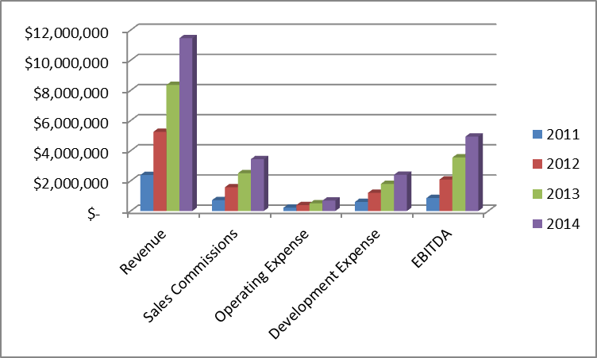

Financial Worksheet

Revenue |  |  |  | 30% Sales |  | Operating |  | Development |  | Total |  |  | % of
New Stories | 2nd Year Stories | 3rd Year Stories | Total | Commissions |  | Cost |  | Cost |  | Expenses |  | EBITDA | Revenue
$ 2,388,000 | $ - | $ - | $ 2,388,000 | $ 716,400 |  | $ 214,920 |  | $ 600,000 |  | $ 1,531,320 |  | $ 856,680 | 36%
$ 4,776,000 | $ 477,600 | $ - | $ 5,253,600 | $ 1,576,080 |  | $ 394,020 |  | $ 1,200,000 |  | $ 3,170,100 |  | $ 2,083,500 | 40%
$ 7,164,000 | $ 955,200 | $ 238,800 | $ 8,358,000 | $ 2,507,400 |  | $ 501,480 |  | $ 1,800,000 |  | $ 4,808,880 |  | $ 3,549,120 | 42%
$ 9,552,000 | $ 1,432,800 | $ 477,600 | $ 11,462,400 | $ 3,438,720 |  | $ 687,744 |  | $ 2,400,000 |  | $ 6,526,464 |  | $ 4,935,936 | 43%
 |  |  |  | Revenue | Sales Commissions |  | Operating Expense |  | Development Expense |  | EBITDA
 |  |  | 2011 | $ 2,388,000 | $ 716,400 |  | $ 214,920 |  | $ 600,000 |  | $ 856,680
 |  |  | 2012 | $ 5,253,600 | $ 1,576,080 |  | $ 394,020 |  | $ 1,200,000 |  | $ 2,083,500
 |  |  | 2013 | $ 8,358,000 | $ 2,507,400 |  | $ 501,480 |  | $ 1,800,000 |  | $ 3,549,120
 |  |  | 2014 | $ 11,462,400 | $ 3,438,720 |  | $ 687,744 |  | $ 2,400,000 |  | $ 4,935,936

Appendix A

Windows Phone 7 Designs

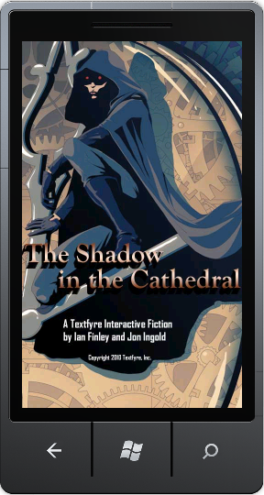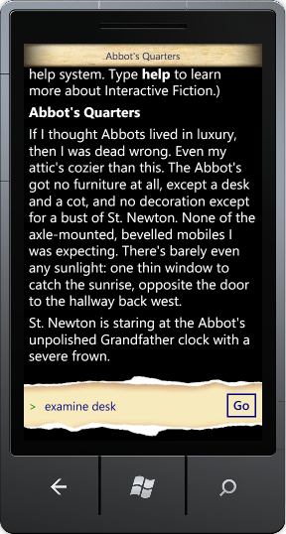
Kindle Design
